**CASE STUDY ON ROLLING DISPLAY**

**by**

**Jawwad Kazi (Roll no.-32)**

**Ashish Singh (Roll no.-81)**

**…………………**

*under the guidance of*

**Prof.Suraj Shete**



Department of Information Technology

Finolex Academy of Management and Technology, Ratnagiri

October 2018

Rolling Display Using 8051

A Rolling display can be seen everywhere these days. All new buses are equipped with this display so as to provide useful information to the travelers. It is also used as an advertising board. A string of characters is rolled from right to left generally on the LCD screen. The need for rolling display arises if the length of the string to be displayed is bigger than the number of characters the LCD can display at on go. For example, 16x2 LCD can display only 16-characters on a single line. If the length of the string is more than 16,then the string is rolled.

The circuit consists of an 89c51 controller and a 16x2 LCD, LM016L.

The circuit is tested on Proteus software. The demo version of it is freely available on internet. The internal

frequency has been set to 11.0592MHz. Output on LCD.

The string is “**STUDENTS OF TE IT**”

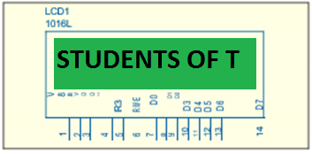

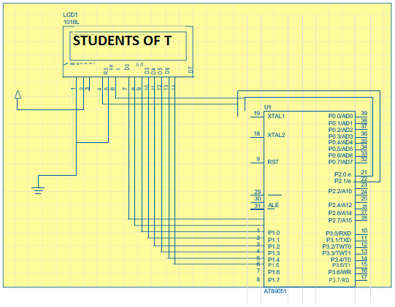



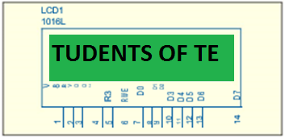

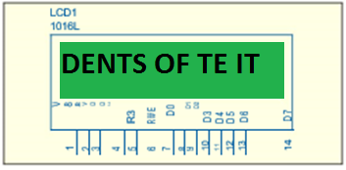

**8051 Controller**

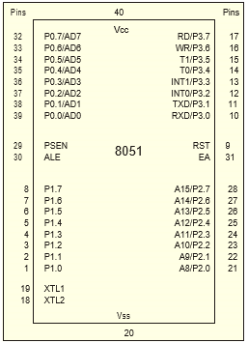

The 8051 architecture consists of these specific features:

8-bit CPU with registers A (the accumulator) and B 16-bit program counter (PC) and data pointer (DPTR)

8-bit program status word (PSW) RAM of 128 bytes and ROM of 4K

Four register banks, each containing 8 registers 32I/O pins organized as 4 ports P0-P3 Two 16 bit timers, T0, T1

Two external and three internal interrupt sources Oscillator and clock circuit

**16x2 LCD**

The LCD used is LM016L.It has got an inbuilt controller HD447800.It needs 5V to operate. In the HD447800, we can send the data in either 4bits which needs two operation or in 8 bits. When interface data is 4 bits long, data is transferred using only 4 buses of DB4~DB7 and DB0~DB3 are not used. Data transfer between the HD44780 and the MPU completes when 4bit data is transferred twice. Data of the higher order 4 bits (contents of DB4~DB7) when interface data is 8 bits long).

When interface data is 8 bits long, data is transferred using 8 data buses of DB0~DB7.

The LCD panel's Enable and Register Select is connected to the Control Port. The Control Port is an open collector / open drain output. While most Parallel Ports have internal pull-up resistors, there are a few which don't. Therefore, by incorporating the two 10K external pull up resistors, the circuit is more portable for a wider range of computers, some of which may have no internal pull up resistors. The 10k Potentiometer controls the contrast of the LCD panel.

The 2-line x 16-character LCD modules are available from a wide range of manufacturers and should all be compatible with the HD44780.

The pin out on most LCD's will be 14 to 16 pins in a single row with the standard 100 mil spacing. The 16 pin version has two extra pins to accommodate a back-light. However, sometimes the pins are present but not connected to anything.

There are two basic ways to interface the device: 8-bit mode and 4-bit mode. Most often, the "R/W" line is just tied to ground, and the LCD is only written to and not read. The read function is usually used to poll the "Busy Flag" which appears on D7 while the device is incapable of accepting a command. However, this function may be ignored by simply waiting the maximum amount of time for each command to complete (most are completed in less than 200us).

The port 1 pins of 8051 controllers are connected to the data pins of LCD.RS pin of the LCD is used to differentiate the ‘displaying data’ and LCD commands. If ‘1’, the sent data is displayed on the LCD. If ‘0’, it is used as a LCD command. In the circuit this pin of LCD is connected to second pin of port 2 i.e. P2^1.The enable pin of LCD, E is connected to first pin of port 2, P2^0.To enable the LCD, a High to Low pulse is sent to this pin.

The R/W is pin grounded and Vee is not connected.

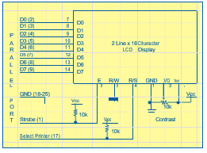 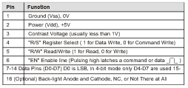

Program Code

#include <REGX51.H> //Header File

#define PORT P1 //Defining macro for Port1

sbit RS=P2^1;

sbit EN=P2^0; //Delay function

void delay(unsigned char x)

{

unsigned int p,q;

for(p=0;p<x;p++)

for(q=0;q<1275;q++);

}

//LCD command Function

void lcd_cmd(unsigned char a)

{

PORT = a;

RS = 0;

EN = 1;

delay(1);

EN = 0;

}

//LCD initialize Function

void lcd_init()

{

lcd_cmd(0X01); //Clear Display screen

lcd_cmd(0X8F); //Force Cursor to end of first line

lcd_cmd(0X0C); //Display ON cursor OFF

}

//LCD Data Function

void lcd_data(unsigned char b)//The data which is to be display is passed

{

PORT = b; //sending the data on port1

RS = 1;

EN = 1;

delay(1);

EN = 0;

}

//Function for paasing the String

void lcd_string(unsigned char* ptr)

{

unsigned char *str;

unsigned int len=0,i,j,k;

unsigned char pos=0x8f;

str=ptr;

while(*str++)//Calculating length of string

{

len++;

}

for(i=0;i<len;i++)

{

delay(50);

lcd_cmd(0x01);

}

}

//Main Function

void main()

{

lcd_init(); //Function to initialize the LCD

while(1)

{

lcd_string("STUDENTS OF TE IT"); /*Passing string to the function*/

}

}

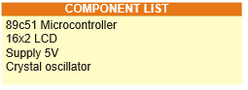

Mr. Kazi Jawwad A Rahim

Mr. Singh Ashish Kumar